AWS ELASTIC BEANSTACK

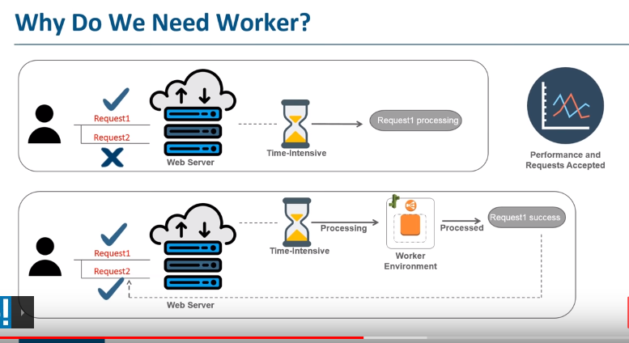

Placing of worker environment in aws elastic beanstack

# How does worker environment works

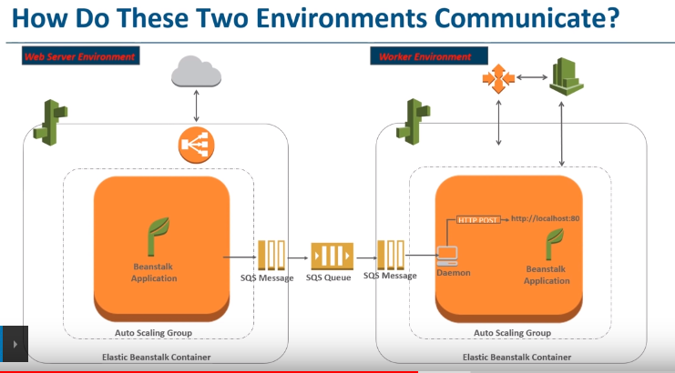

user send requrest to web application > SQS takes request and sends to SQS queue > SQS queue set the order based on the priority > meanwhile worker environment is being installed , elastic beanstack will install deamon > deamon pull the SQS meassage from SQS qury & send to web application which is running in worker environment > this application resolve all the task & sends http response. This is how your two app communicate

POINTS TO BE NOTED:-

* Create elastic beanstack
* Deploy application
* Continues Deployment (changing version)
* Creating multi environment stage for application (clone environment)
* Blue/Green Deployment (Swapping URL)